Center for Computing in the Liberal Arts

Handbook

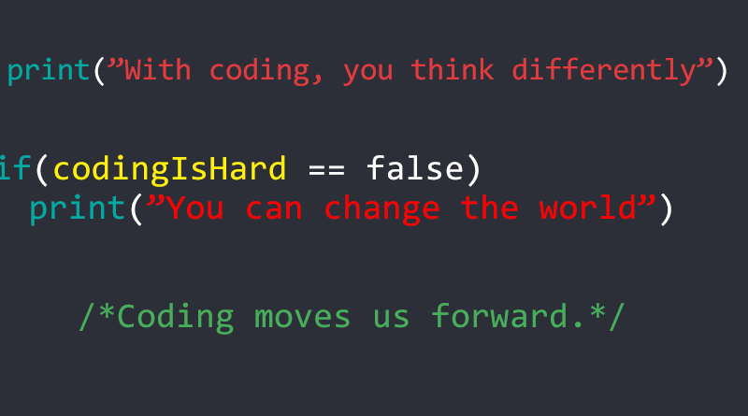

Cover image source: Garcia, Henley. MDC The Reporter. 2017, Jan 27. <https://www.mdcthereporter.com/why-should-you-learn-to-code/>

## Introduction

Welcome to the CCLA! Hopefully, this will be a guide for you throughout your time employed at the CCLA. As a peer consultant, you will be expected to help people who come into the center with a coding problem to solve. You will aid them in learning the appropriate code to solve the problem, and will be there t-o help troubleshoot the final code.

## Mission Statement

The mission of the Doane Center for Computing in the Liberal Arts is to provide students and faculty with computer code training and support to more effectively accomplish their research and personal computing goals. We train knowledgeable peer consultants for all disciplines at any stage in a computer project.

What is expected of a CCLA employee?

Dress Code

While there is not a certain way you need to dress when working, we do ask that you dress in an approachable way. What does this mean? This means that you should present yourself in a way that allows someone entering the CCLA to feel like they are welcome here. Try to avoid super extremes of behavior and dress that may seem off-putting to some.

Interacting with Collaborators

We should treat our collaborators in a way that makes them feel comfortable and welcome. In general, we should operate under the Golden Rule, and treat our collaborators the way we would like to be treated if we were in their shoes. We want to help our collaborators with what they came in for, and we want to make it an enjoyable experience. Coding can seem scary the first couple times you do it, and we want to be a face that helps guide them through this journey.

Free Time at Work

There will be times when you have finished what you needed to get done for your time at work. When you have this free time, you are open to doing what you would like. We just ask that you don’t do something that you won’t be able to pause doing in case a client comes in for help or the director needs you to do something.

Useful Coding Appendices

For examples of common coding languages, please see the director of the CCLA, or SoloLearn’s FAQ on “Which Language Should I Learn First?”

What are some things to do while you code?

As you write your code, there a few things to keep in mind. First, comment on the code! Comment what each line does, and put a comment block at the top explaining what the code does as a whole. You may think that you’re commenting too much, but you will be happy when you have to look back on the code after it is done and you’ll be able to find everything. Commenting also helps us figure out where errors are. If you have a line that’s supposed to do something, and you know what it’s supposed to be doing, having a comment on the line makes it easy to look at it to see if the line is actually doing what you want it to do.

Second, add white space. This means add blank lines wherever you can. This makes it a lot easier to read your code. A good thing to think about with white space is thinking about your code like a list. After each “step” in your list, you should add white space (just as you add space between items in a written list).

Thirdly, keep things simple. Always choose the simplest option to execute something first, and then slowly work to more complex options if the first didn’t work. If you start with the most complex option, you may not be able to figure out what that line does when you read through your code later. If you do want to use a complex option, be extra sure to comment what it is doing so you aren’t confused when you read your code back.

Fourth, code consistently. Keep indents and white space consistent throughout all of your coding projects. This helps not only with reading your code later but also helps you find certain parts of the code because it looks the same in all of your coding projects.

Fifth, when naming things, keep names descriptive of what they are. This can help you while you are coding, so you don’t have to constantly look back and see what you named things.

Sixth, do not try and code everything in one sitting. It can very difficult to code when you are tired, and you will end up making more mistakes. Break your coding time into one to two-hour shifts, then a break. When you take a break, change your scenery. Even just walking down the hall and back again can help your brain focus on something else. This then helps you refocus on the task.

How to get an HPC account

This is really easy. You just need to contact the director of the CCLA, and he will get you set up with an account. When you do have one, you just need your Doane email and password to log in. If you operate in Windows, you will need to download MobaXTerm in order to access. Ask the director for help in downloading this.